Student Course Registration System
Branch: Data Science Section: 2 Batch No:02
Student Roll No’s : 24B11DS072, 24B11DS002, 24B11DS008, 24B11DS021
Student Name’s: G BHANU TEJA, A MADHAN, A PAVAN TEJA , B SIVA SRINU
Faculty Name: K . Syamala Kalyani

Introduction

The Student Course Registration System is a desktop-based application designed to modernize and simplify the process of academic enrollment and course management. In many educational environments, managing student records and course allocations manually through spreadsheets or paper-based files is a common practice. However, these traditional methods often lead to significant challenges, including data redundancy, errors in enrollment records, difficulty tracking course capacity, and the risk of physical data loss.
To address these inefficiencies, this project introduces an automated solution that provides a centralized platform for administrators and students to interact with academic data securely and accurately. The system is built using Java Swing for the graphical user interface, providing a professional and intuitive desktop experience, while leveraging MySQL for robust, relational data storage
This application is developed using:
- Java (Core Java)
- JavaSwing (Frontend)
- JDBC
- MySQL Database

Problem Statement

In many educational institutions, student enrollment and course management are still handled through manual processes, such as paper-based records or basic spreadsheets. These traditional methods are often inefficient and lead to several critical issues.
- Data Redundancy
- Accuracy and Errors
- Course Capacity Management
- Time-Consuming Updates
- Security and Data Loss
Therefore, there is a clear need for an automated, desktop-based system that ensures data integrity, improves administrative speed, and provides a secure environment for managing academic records.

Objectives of the Project

The primary goal of this project is to develop a reliable and efficient desktop application using Java Swing and MySQL
- To store and manage student, course and rigistrations data within a structured MySQL database.
- To allow admin to add and manage Students and courses
- To enable admin to register students to the courses
- To prevent duplicate enrollments
- To track enrollment count per course
- To display data in an easy-to-use interface

Scope of the Project

The system can be used in:
- Universities
- Colleges
- Training institutes
- Academic departments
The system allows authorized users (admin) to manage course and enrollment data through a Desktop application.

Modules Description

The Student Course Management System consists of the following modules:

Login & Authentication Module

This module serves as the entry point for the application. It provides a secure interface for administrators and users to log in with their credentials.
- Admin Login: Grants access to full system controls.
- User Registration: Allows new users to create accounts and store their details in the database.

Student Information Module

This module is responsible for capturing and maintaining comprehensive student records.
- Profile Management: Captures details such as Name, Date of Birth, Age, and Department through a specialized form.
- Automatic ID Generation: Ensures every student is assigned a unique identifier (e.g., STU100) automatically.

3. Course Management Module
This module handles the administrative side of the curriculum.
- Course Entry: Facilitates adding new courses by defining the course name, duration, and associated costs.
- Curriculum Tracking: Manages course IDs and detailed content descriptions for each subject.

5. Enrollment & Allotment Module
The core of the application, this module maps students to their chosen courses.
- Registration Processing: Links unique Student IDs to specific Course IDs.
- Validation: Prevents duplicate enrollments for the same student in a single course.
- Capacity Tracking: Maintains an enrollment count for each course to monitor availability.

6. Database Connectivity Module (JDBC)
This background module acts as the bridge between the Java Swing frontend and the MySQL database.
- Query Execution: Handles the execution of SQL commands like INSERT, SELECT, and DELETE.

Persistence: Ensures all data entered through the GUI is stored securely and can be

User Interface Design

Login window:

This window allows authorized admin to enter their AdminID and password to access the Student Course Registration System.
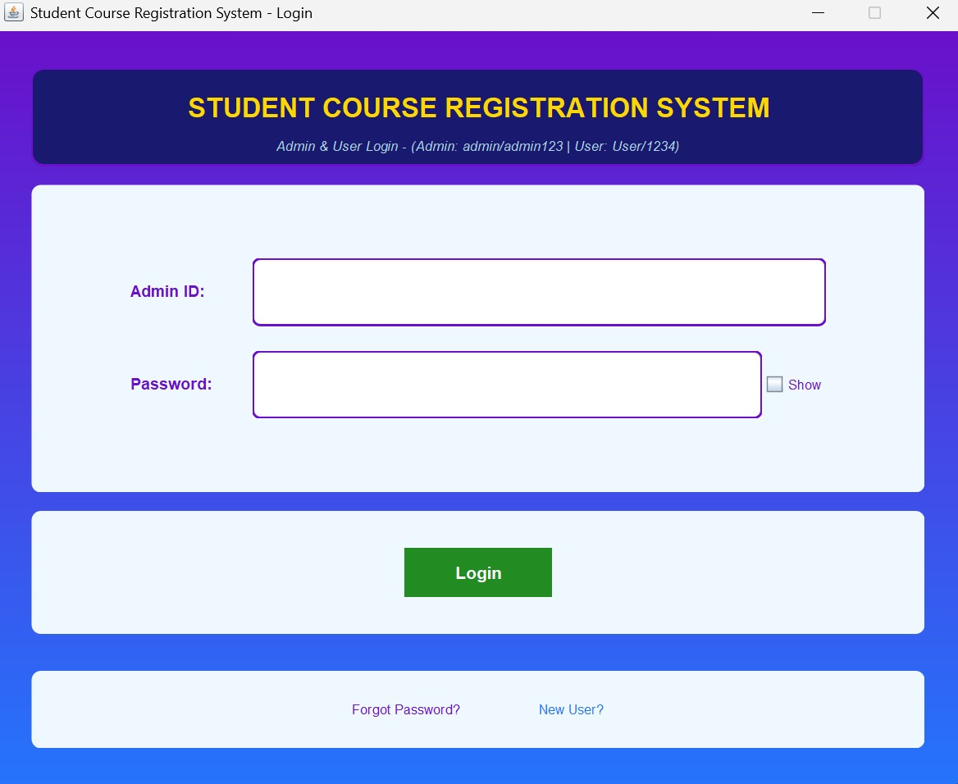

Main Dashboard:
This is the central interface of the system that provides navigation to new student entry, new course adding into the database and Course Registration operations. Only the admin can access all the three operations

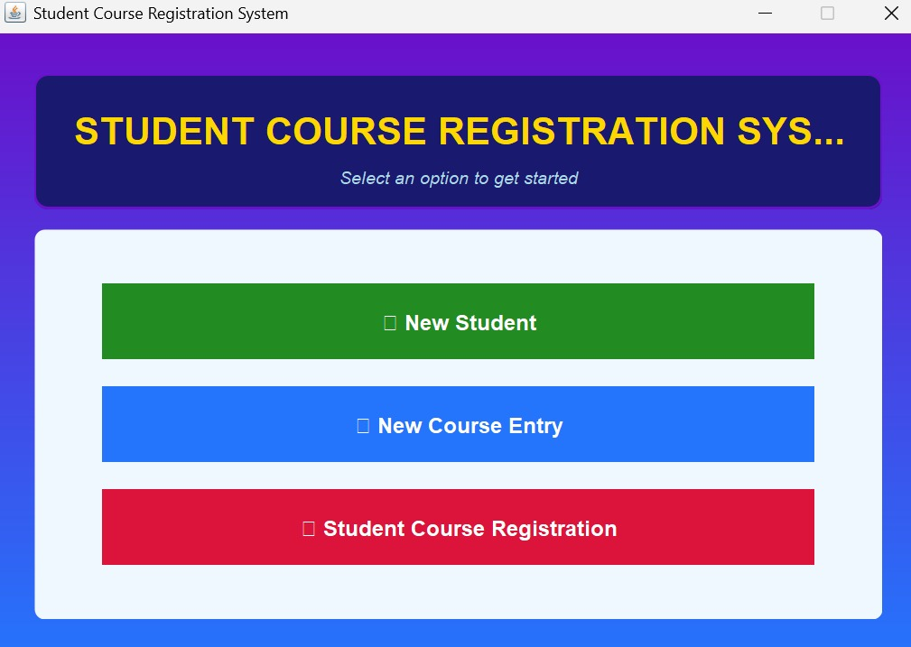

Student Data Entry Window:

This window allows admin to add new students by entering personal data. The information is stored securely in the database for future Usage like registration process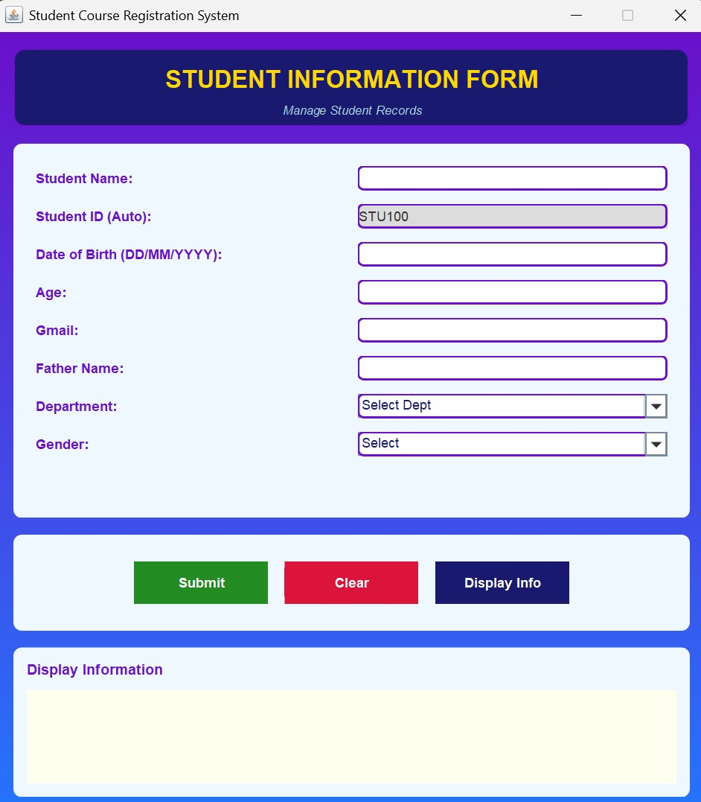

New Courses Entry Window:

This window helps to add new courses, so that students can enroll. In this we add course based on course ID, course name, Course content, course cost.

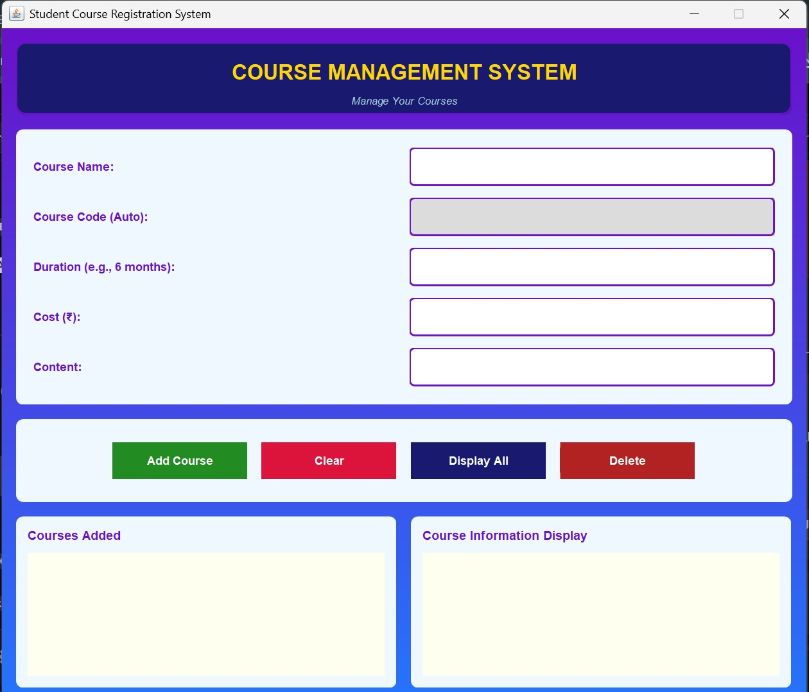

Student Course Registration Window:

This window helps the user to allot the courses to the user which are available in the database and store the registration details in the data base



